**Task 5**

1. WAP for multiplication and division using function

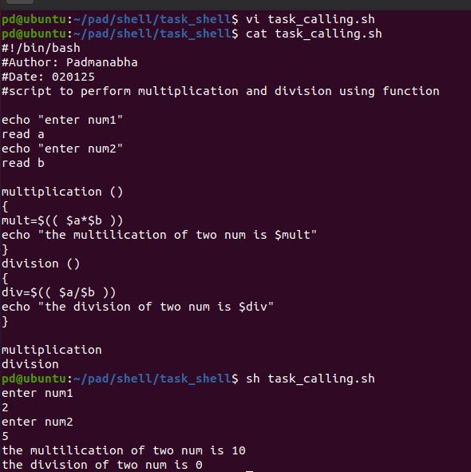

1. WAP to perfom the free , du , df uname , ps , top , ping , netstat and call any 4 using function

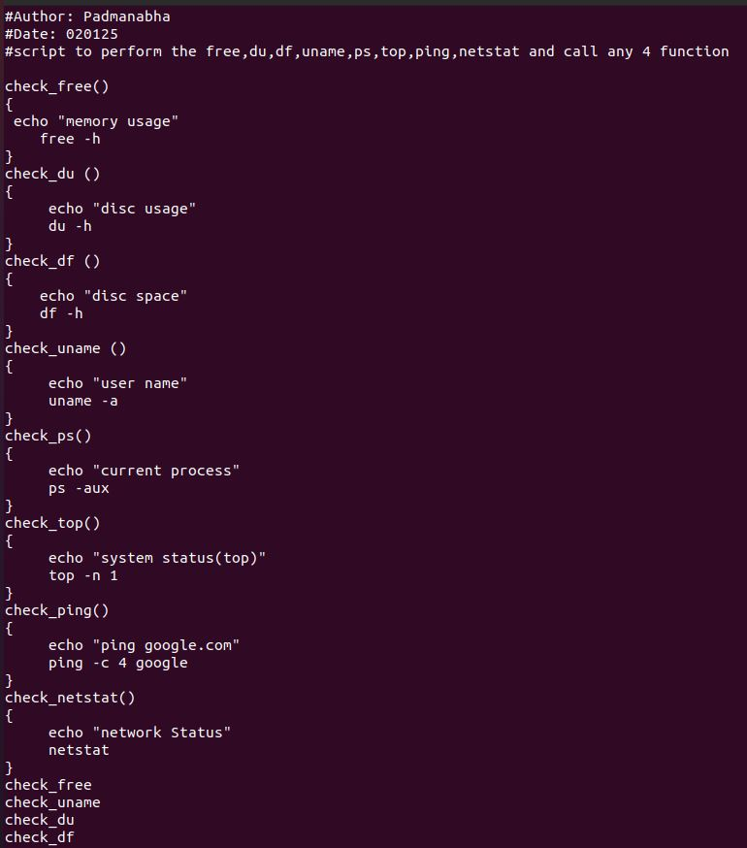

**O/P**

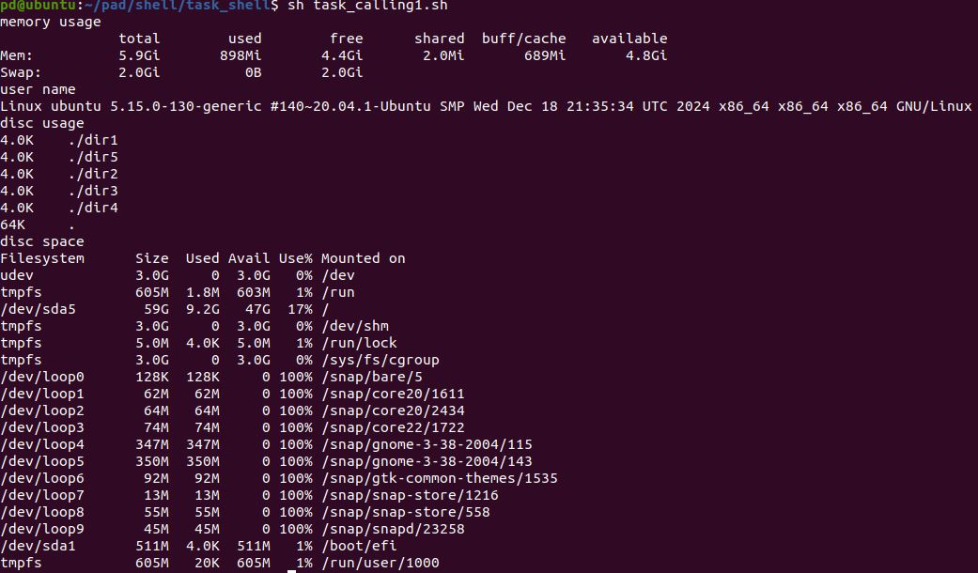

1. create a empty file via cron job

step:1

create an empty file by giving path where the file has to be created and run the script

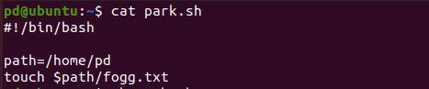

Step: 2

Check whether the file is created or not

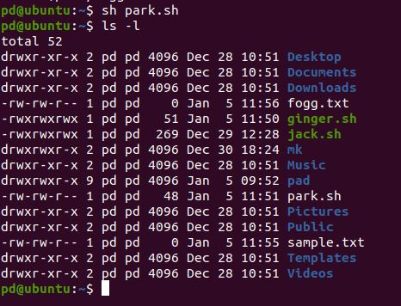

Step: 3

Delete the created file fogg.txt

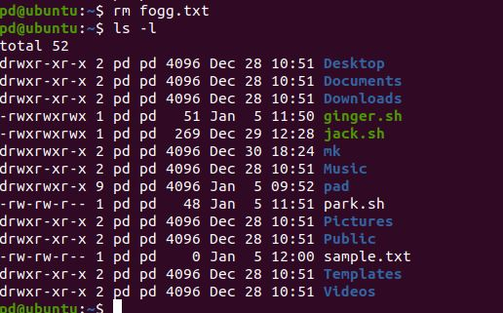

Step: 4

Enable the execute permission

4.JPG

Step: 5

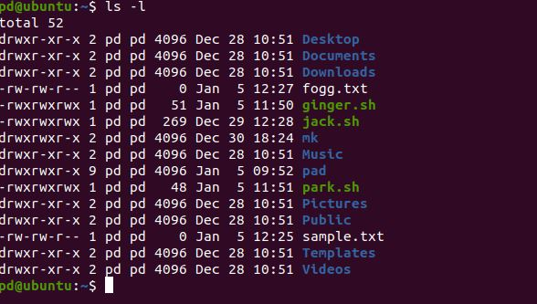

Step: 6

sudo service cron start - on the terminal (For a new user, using cronjob)

Step: 7

**crontab –e** on the terminal (select vi editor)

Step: 8

Then schedule when you want repeat a scheduled task here we are repeating the task every 5 min. details are shown below (in last line)

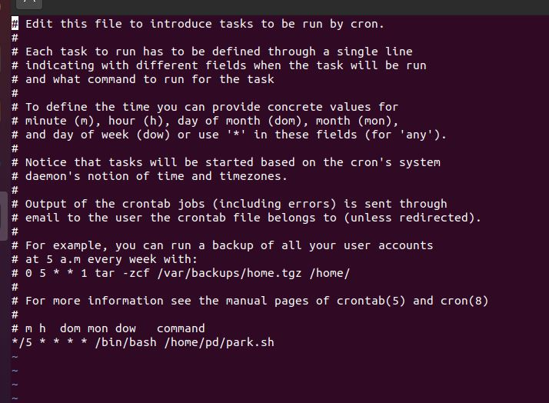

Note:

* * * * * /path/to/command

│ │ │ │ │

│ │ │ │ │

│ │ │ │ └─ Day of week (0 - 7) (Sunday = 0 or 7)

│ │ │ └──── Month (1 - 12)

│ │ └────── Day of month (1 - 31)

│ └──────── Hour (0 - 23)

└────────── Minute (0 - 59)

Step: 9

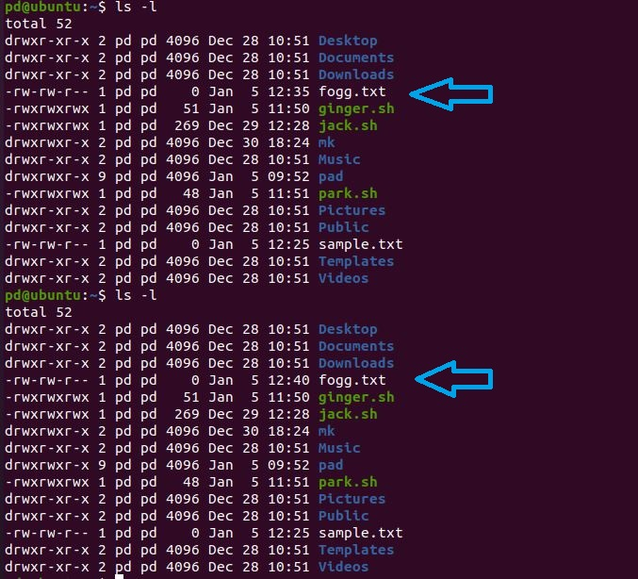

Henceforth the above image shows that every 5 min the file will be updated/created.